**Golden Star Diner Documentation**

1. Word press Admin panel login or website backend login

**URL**: http://www.goldenstardiner.com/wp-admin

**Username: goldenstardiner**

**Password: admin123**

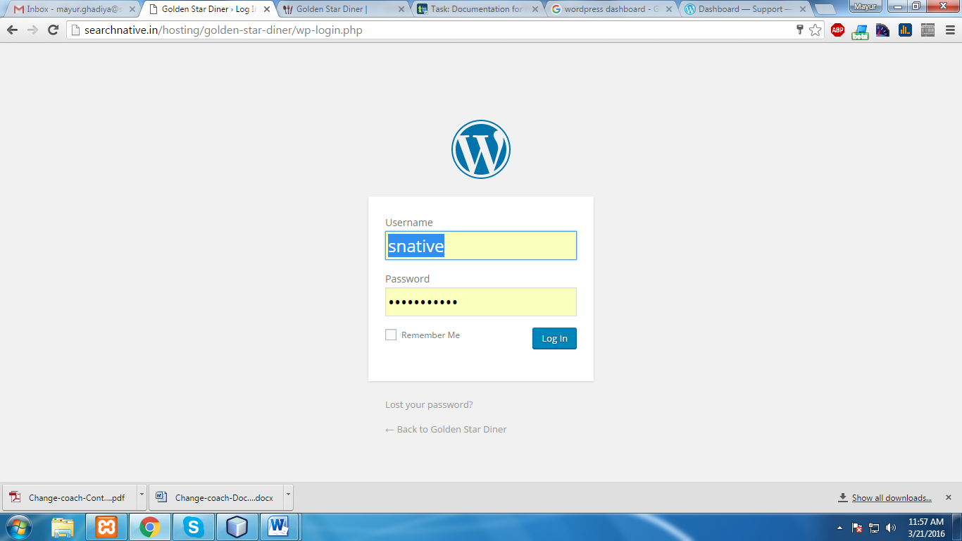

After entering above user credential press `Log in` button.

After login success with admin credential you will see the below page which is called ‘Dashboard’.

The Dashboard (wp-admin) is the first screen you see when you log into the administration area of your blog. Or you can get to the dashboard anytime by adding /wp-admin to the end of your site’s url.

The main idea of the dashboard is to give you a place where you can get an at-a-glance overview of what’s happening with your website. You can catch up on news, view your draft posts, see who’s linking to you or how popular your content’s been, quickly put out a no-frills post, or check out and moderate your latest comments. It’s like a bird’s eye view of operations, from which you can swoop down into the particular details.

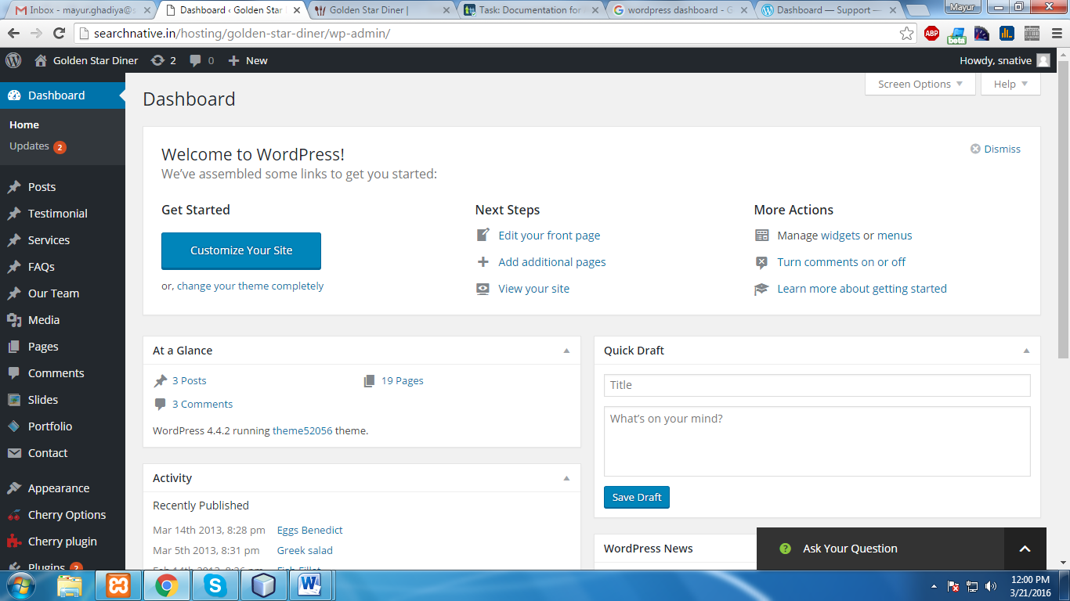

1. Settings
2. General

This Settings- General Screen is the default Screen in the Settings Administration and controls some of the most basic configuration settings for your web site: your web site's title and location, who may register, an account at your site, and how dates and times are calculated and displayed.

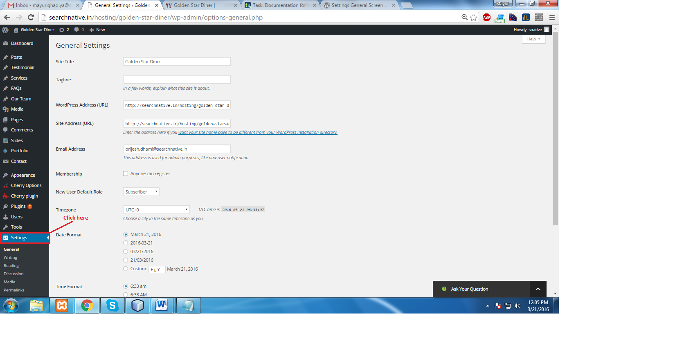

**General settings**

Using general settings, admin can change the following site details.

* Site title: *enter the name of your site here.*
* Tagline: *in a few words, explain what your site is about.*
* Email address: *this address is used for admin purposes, like new user notification.*
* Membership: *check this checkbox if you want anyone to be able to register an account on your site.*
* New user default role: *this pull-down box allows you to select the default Role that is assigned to new users.*
* Timezone: *from the pull-down box, choose a city in the same timezone as you.*
* Date format: *the format in which to display dates on your site.*
* Time format: *the format in which to display times on your site.*
* Week starts on: *select your preferred start date for wordpress calenders from the drop-down box. Monday is the default setting, meaning a monthly calendar will show Monday in the first column.*

***Note: click the `Save Changes` button to ensure any changes you have made to your settings are saved to your database.***

1. Writing

Use the Settings Writing Screen to control the interface you use when writing new posts. These settings control WordPress's features in the adding and editing posts, Pages, and Post Types, as well as the optional functions like Remote Publishing, Post via e-mail, and Update Services.

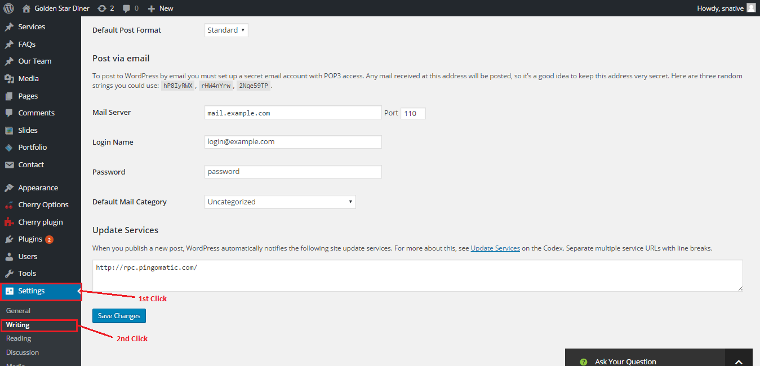

Writing Settings:

* Default post category: *The Category you select from this drop-down is called the default post Category.* *The default post Category is Category assigned to a post if you fail to assign any other Categories with writing your post.*
* Default post format: *The Post Format you select from this drop-down is called the default Post Format. Post Formats are used by themes to create different styling for different types of posts.*
* Post via e-mail: *With this option, you can set up your blog to publish e-mails as blog posts. To do this, you would send an e-mail to a specific address you've established for the purpose.*
* Mail server: *A mail server receives e-mails on your behalf and stores them for retrieval. Your mail server will have a URI address, such as mail.example.com, which you should enter here.*
* Port: *Servers usually use port 110 to receive requests related to emails. If your mail server uses a different port, enter that port number here.*
* Login name: *If, for example, the e-mail address that you will be using for the writing by e-mail feature is wordpress@example.com, then 'wordpress' is the Login name.*
* Password: *Enter the password for the above e-mail address here.*
* Default mail category: *WordPress will assign this Category to all of the posts published via the Post by e-mail feature.*

**Note: *Click the `Save Changes` button to ensure any changes you have made to your Settings are saved to your database.***

1. Reading

You can decide if you want to posts or a static page displayed as your website’s front page or main page. You can also adjust how many posts are displayed on that main page.

Reading Settings:

* Front page displays: *Use this setting to determine if your posts or a "static" Page displays as your blog's front (main) page. This setting displays only if you have one or more Pages defined.*
* Blog pages show at most: *Enter the number of posts to be displayed, per page, on your site.*
* Syndication feeds show the most recent: *Enter the number of posts people will see when they download one of your site's feeds.*
* For each article feed show: *Determines whether or not the feed will include the full article or just a summary.*
* Search engine visibility: *Check the Discourage search engines from indexing this site box to ask search engines not to index this site. When the option is checked.*

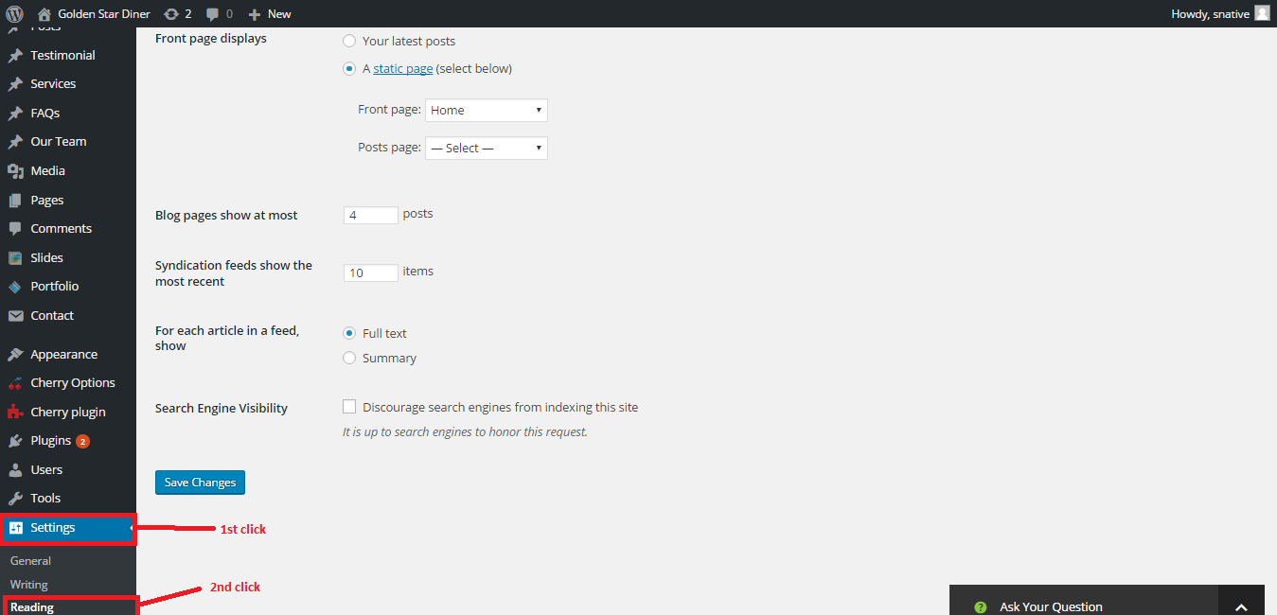

**Changing the Website logo and favicon (theme options) [Plugin]**

**Step1:** Login WP admin panel

**Step2:** Go to Cherry Options > Cherry Option

**Step3:** Click on Logo & Favicon which is available on top of the page

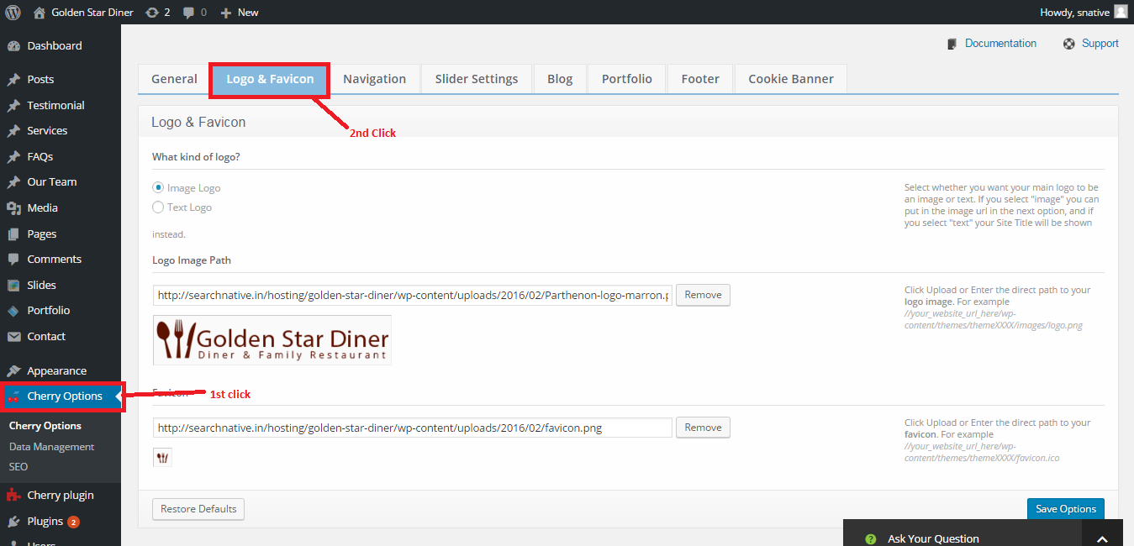

By default Logo image path and favicon is set. If you want to change it, then follows the below step.

**Step1:** Click on remove button

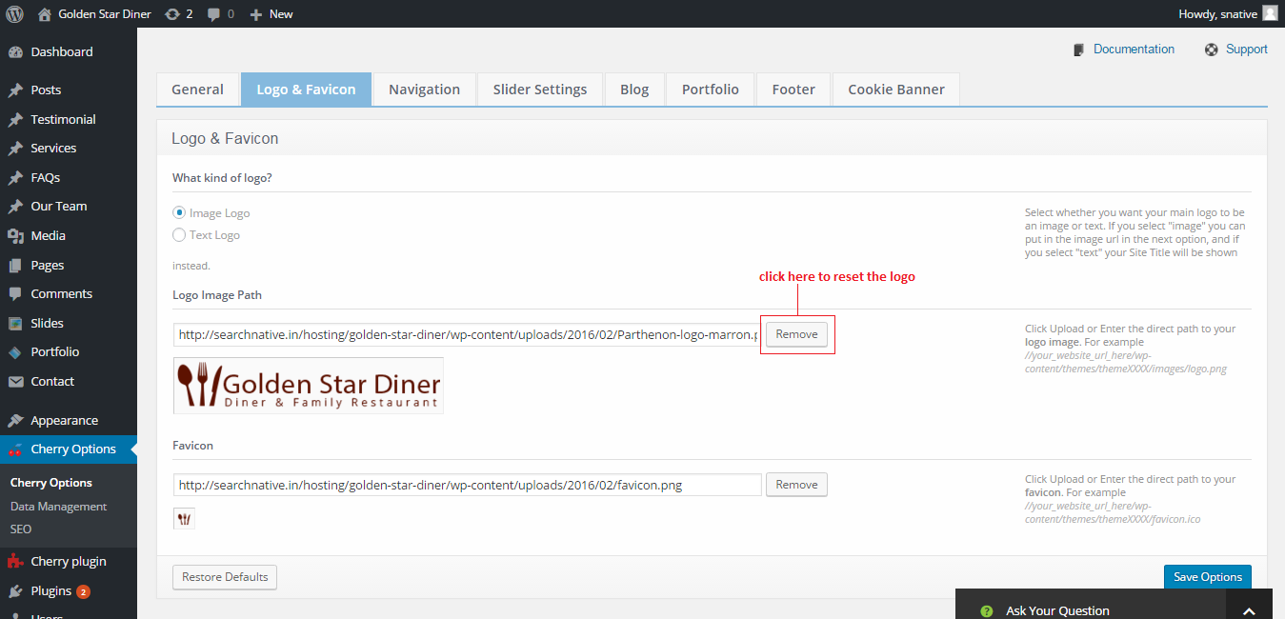

**Step2:** Browse the logo file and select it.

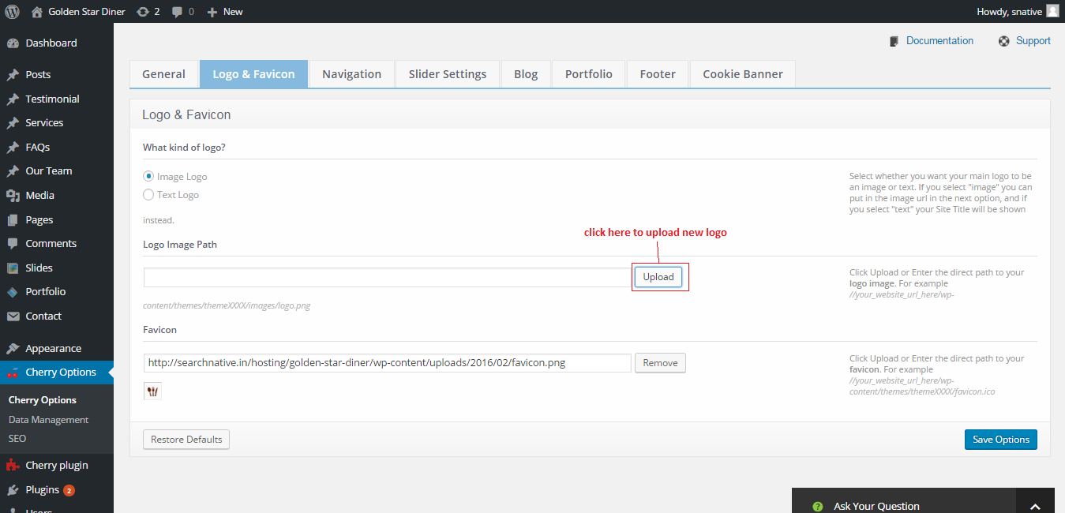

**Step3:** Select exiting image from media library

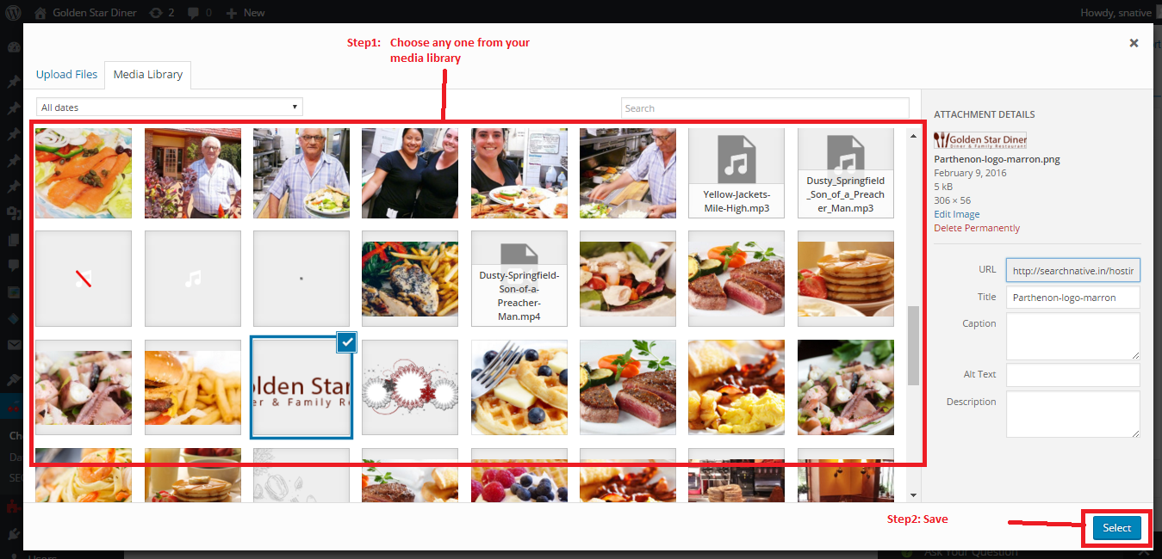

Or admin can also upload new logo file from his/her computer

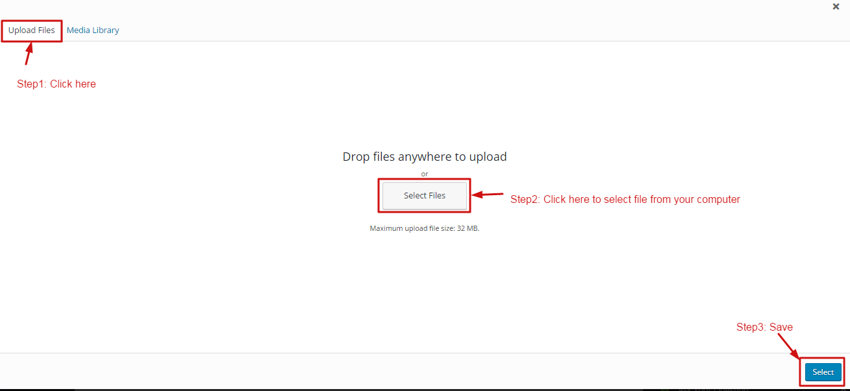

For favicon setting, it follows the same step of the logo setting

**Setting for Navigation**

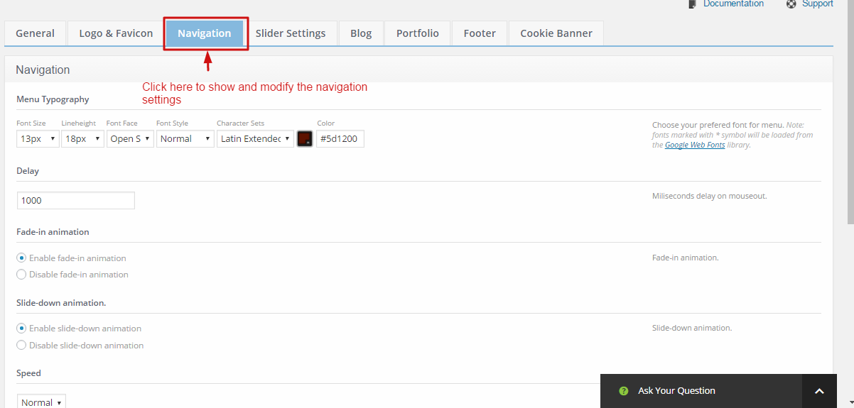

* **Menu typography**
* **Font size:** *set the menu font size in pixels*
* **Lineweight:** *set the lineweight of the font of menu in pixels*
* **Font face:** *set the font type*
* **Font style:** *set the font style. I.e.normal, italic,bold, and bold italic*
* **Character set:** *set the character set i.e.latin, latin extended, greek etc.*
* **Color:** *set the font color of the menu*
* **Fade-in animation**

Enable or disable fade-in animation for navigation

* **Slide down animation**

Enable or disable slide down animation for navigation

* **Speed**

Set the animation speed of the navigation

* **Mobile menu**

Set the text is visible in mobile select menu.

* **Use stickup menu**

Enable or disable stickup menu

**Slider settings**

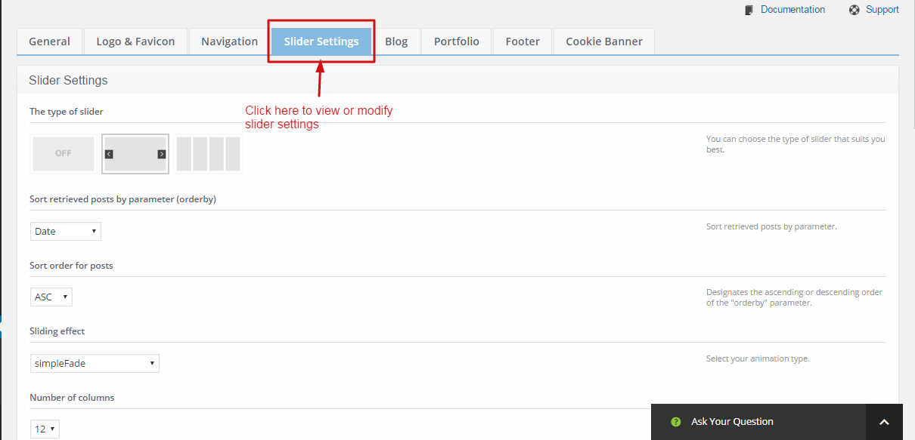

* **The type of slider**

You can select the type of slider based on your requirements.

* **Sliding effect**

Select your animation type of the slider

* **Banner effect**

Select your banner animation

* **Pause time**

Set the pause time of the banner in ms. (default is set for 5000 ms which is 5 sec)

* **Slide show**

Enable or disable animate slider automatically.

* **Next & Prev navigation**

Whether you want to display next and prev navigation on slider

* **Play/pause button**

Whether to show play/pause button on slider

* **Pause on hover**

Pause the slider on mouse hover on the slider

**Portfolio**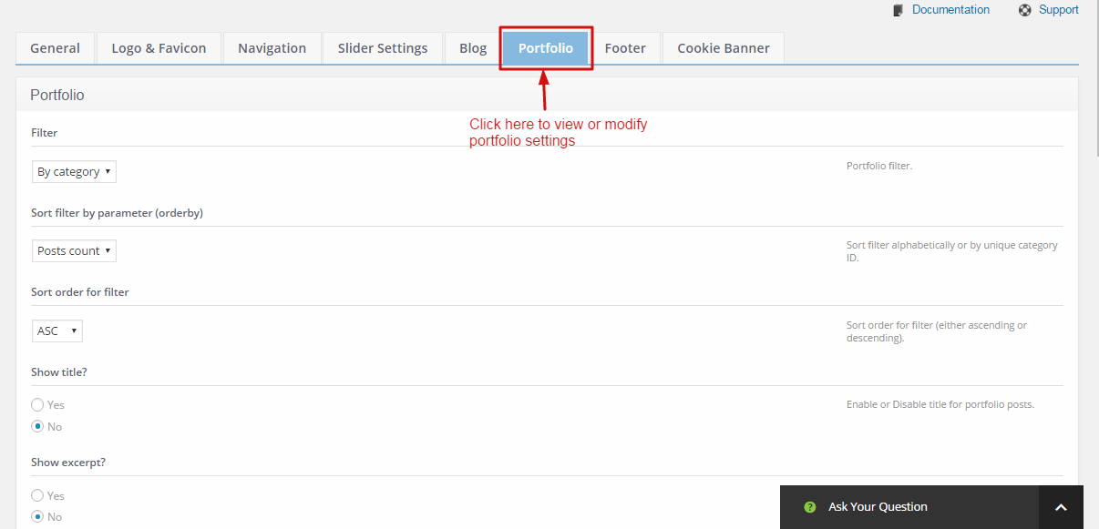

* **Filter**

Select the portfolio filter by category, tags or none

* **Sort filter by parameter(orderby)**

Sort filter alphabetically or by unique category ID.

* **Sort order for filter**

Sort order for filter (either ascending or descending).

* **Show title**

Enable or Disable title for portfolio posts.

* **Show button**

Enable or Disable button for portfolio posts.

* **Button text for portfolio posts**

Button text for portfolio posts. Default is Read more

* **Enable lightbox**

Enable or disable lightbox for portfolio. By enabling this is option image of the portfolio will be shown in lightbox whenever user clicks on it.

* **Gallery format post portfolio layout**

Select the portfolio layout for gallery format post

**Footer**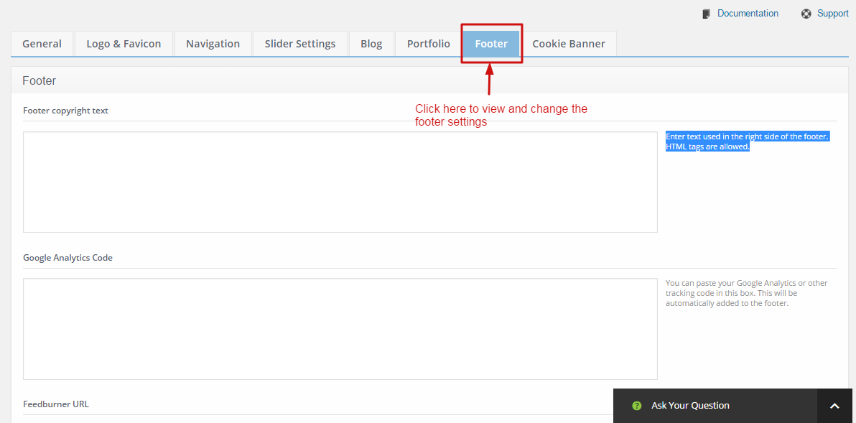

* **Footer copyright text**

Enter text used in the right side of the footer. HTML tags are allowed.

* **Google analytics code**

You can paste your Google Analytics or other tracking code in this box. This will be automatically added to the footer.

* **Feedburner URL**

Feedburner is a Google service that takes care of your RSS feed. Paste your Feedburner URL here to let readers see it in your website.

* **Display footer menu**

Enable or disable to display footer menu

**View and Edit the home page slider**

Admin can easily manage their home page slider by following few steps which is given below.

**Step1:** Go to `Slides` from the navigation and then admin can find the all slides of the slider, where admin can manages(edit or delete) the particular slides of the slider. And admin also can add new slide in slider.

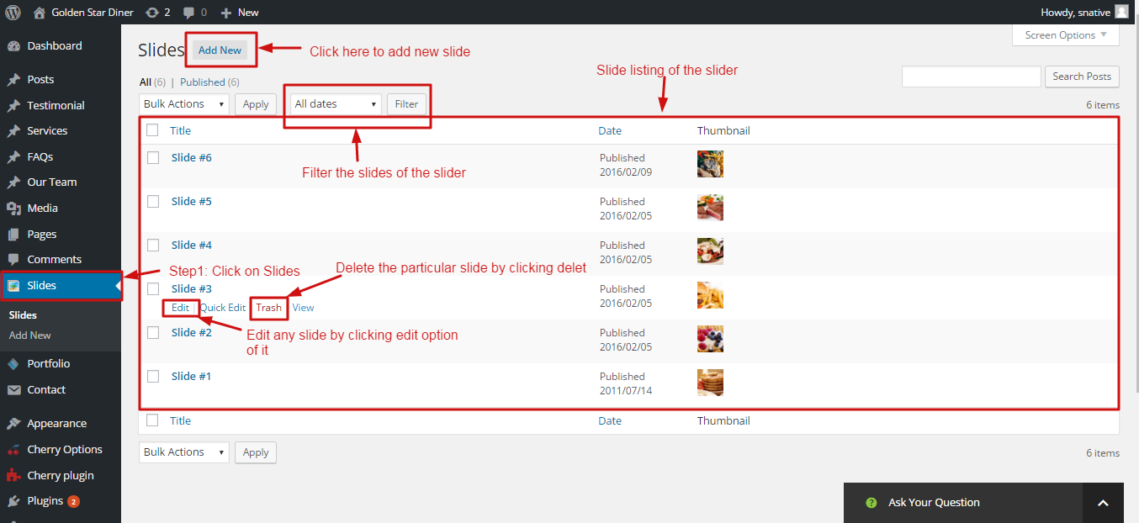

**Step2:** To add new slide, click on `Add New` button and follow the procedure which is shown in below snapshot.

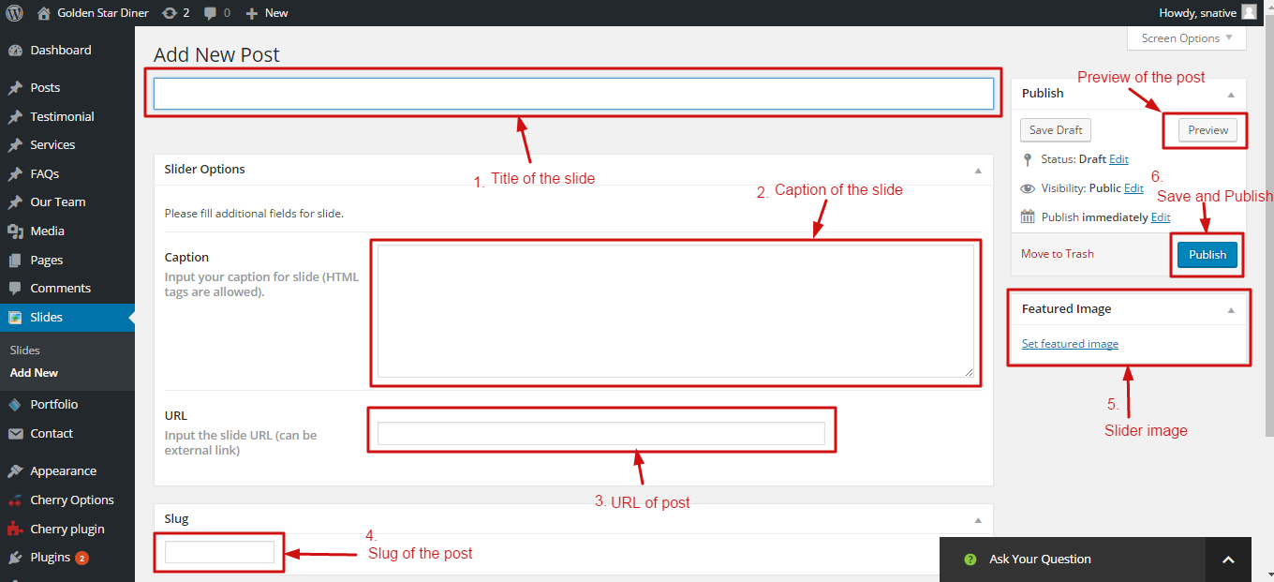

**Manage your portfolio**

Admin can easily manage the website portfolio. Admin can easily insert, edit, and delete the portfolio item by few clicks.

**Step1:** Go to `Portfolio` from the navigation.

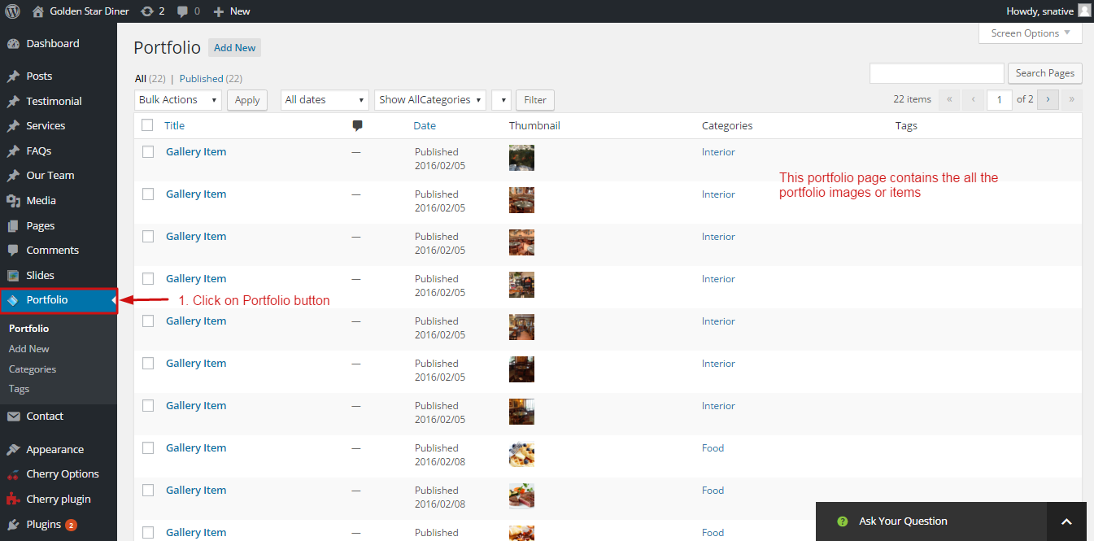

To edit or delete follows below snap

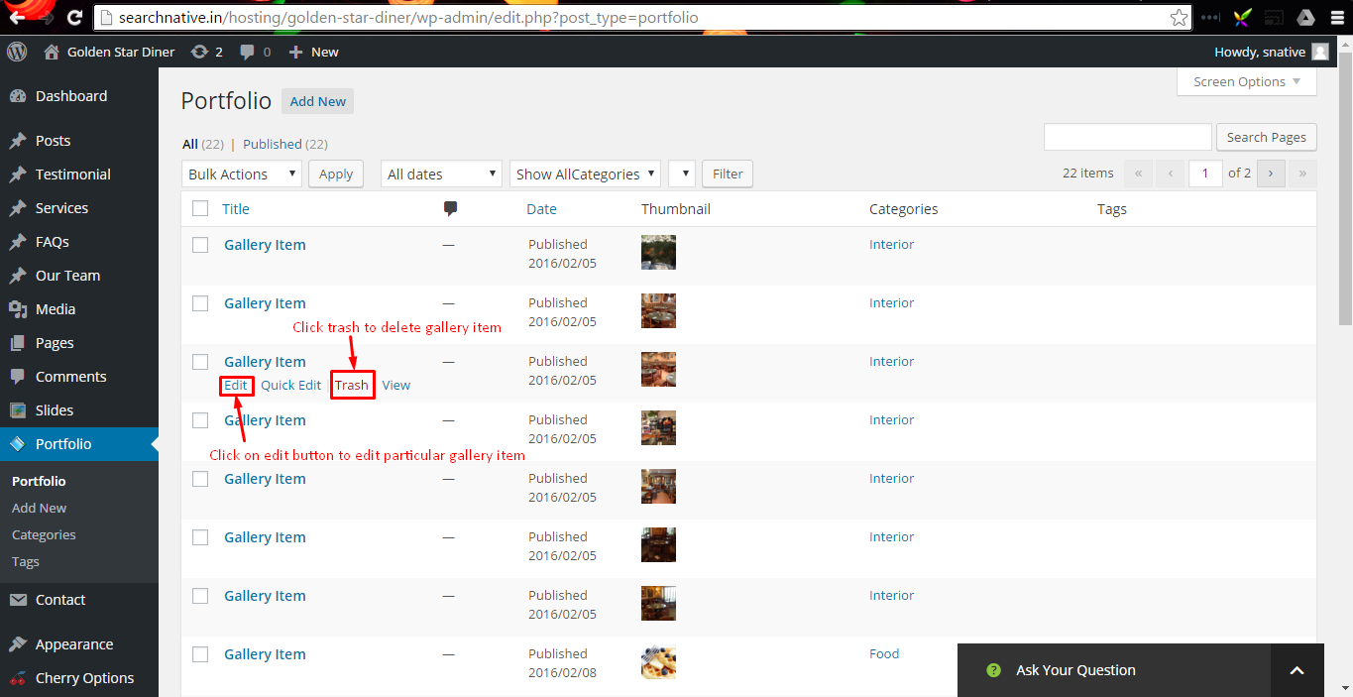

To add new portfolio item follows the below snapshot

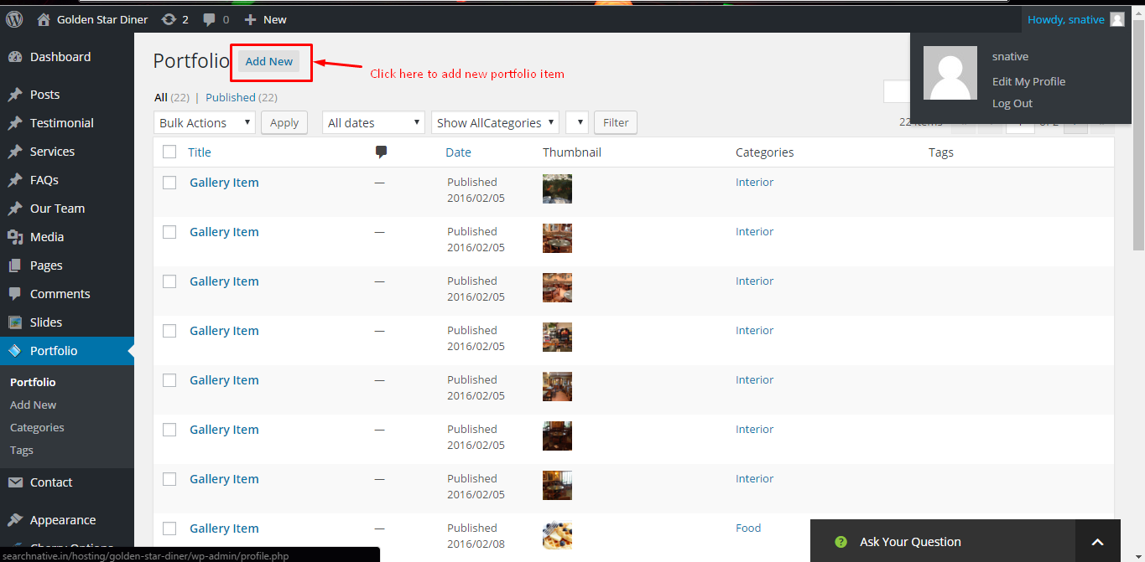

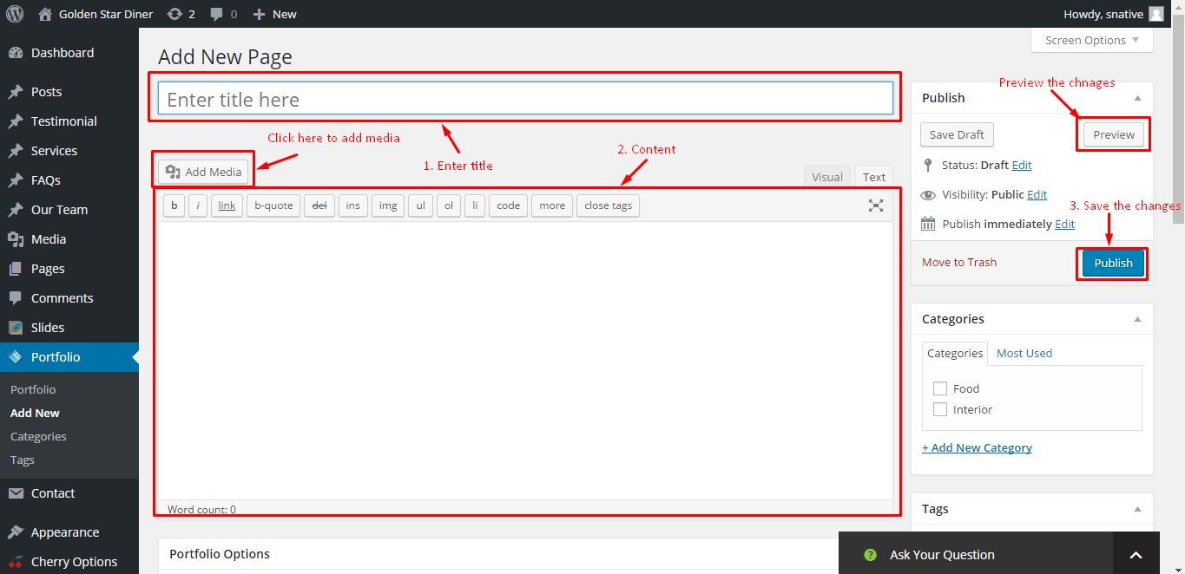

**Manage your contact form**

Admin can easily edit the existing contact form by few clicks.

**Step1:** Go to `Contact` from the navigation

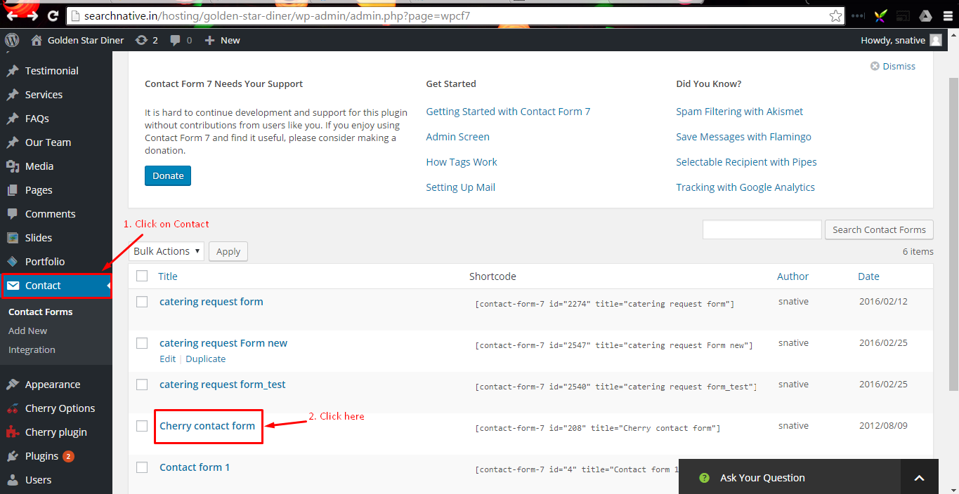

**Step2:** View or edit contact form [Drag & Drop]

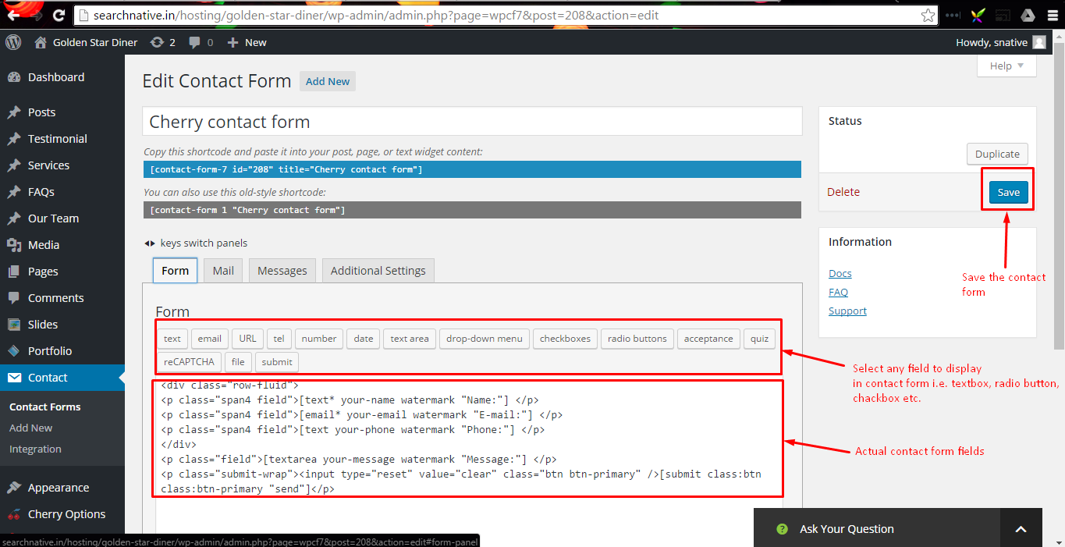

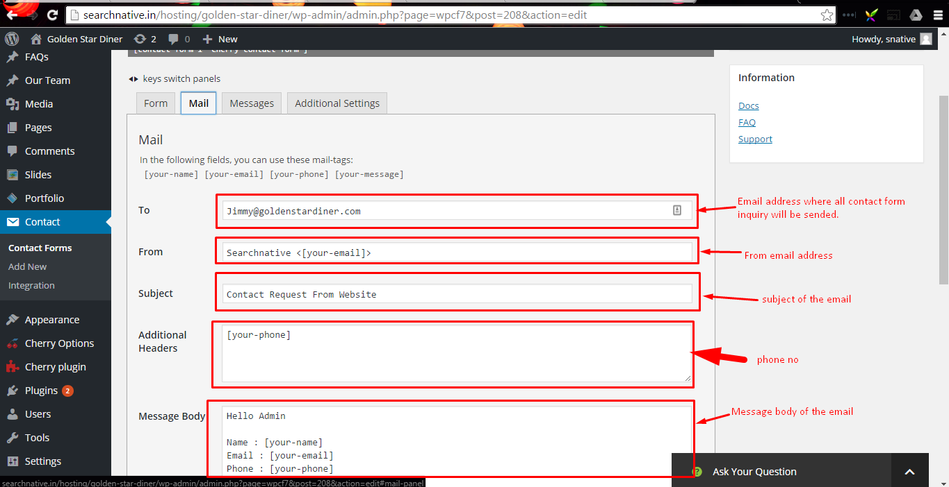

**Manager your website media**Admin can easily upload media files including images and videos from the admin panel. Admin can also edit and delete existing media files.

**Step1:** Go to `Media` from navigation

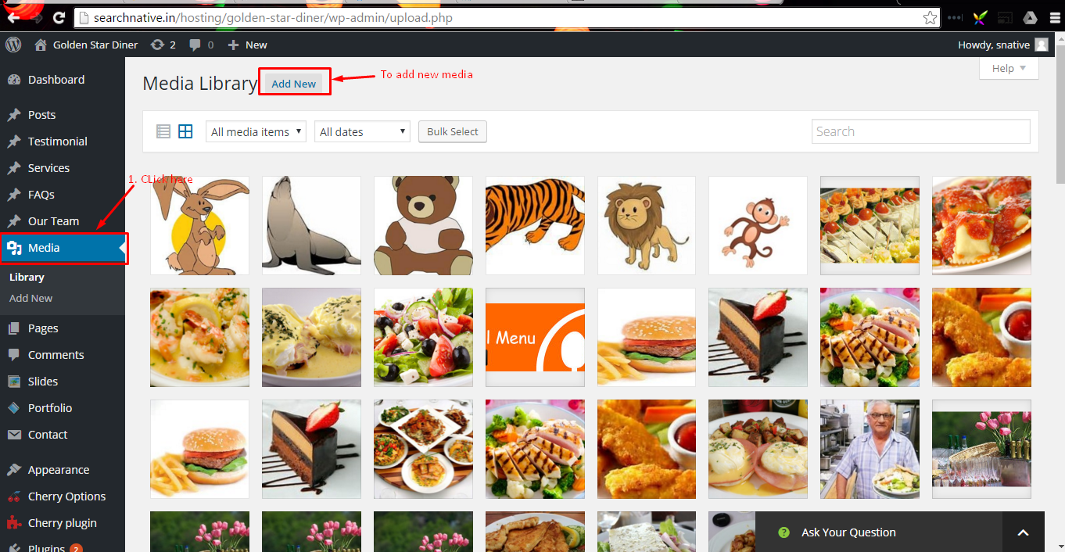

To add new media click on `Add new` button and follows the snapshot

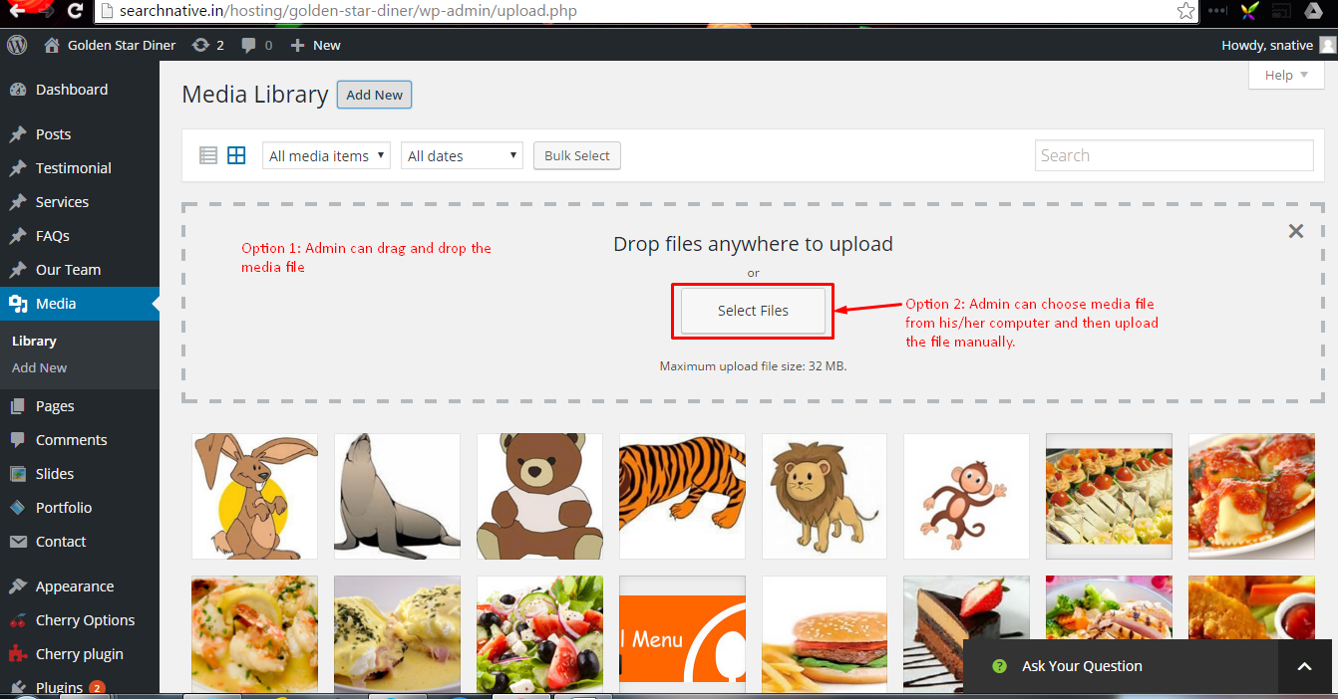

To delete or edit click on particular media item and follows the snapshot

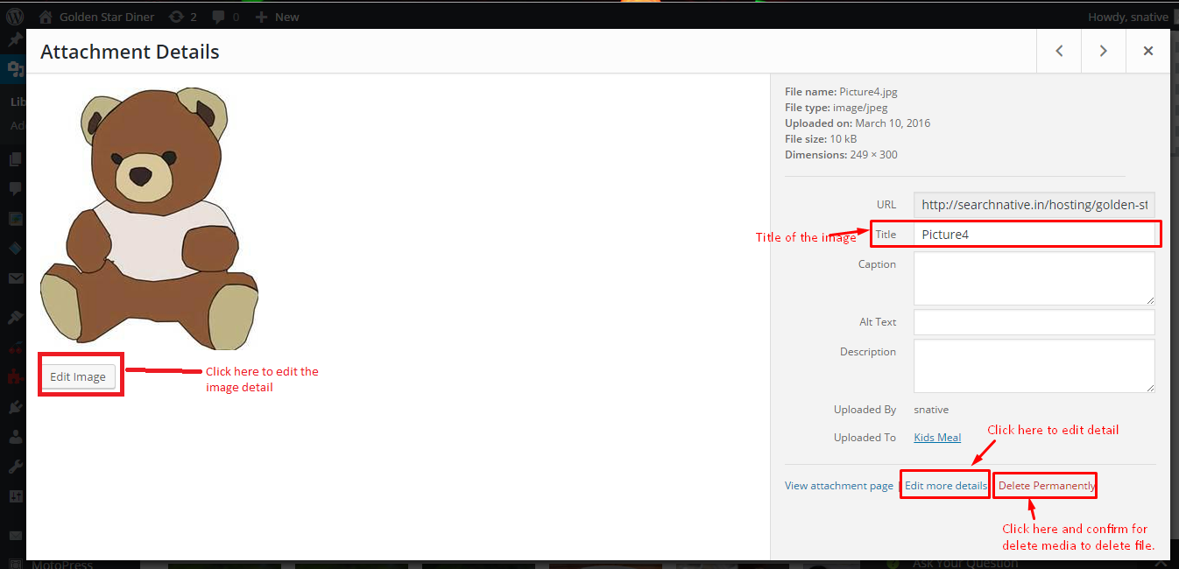

* Today’s Special

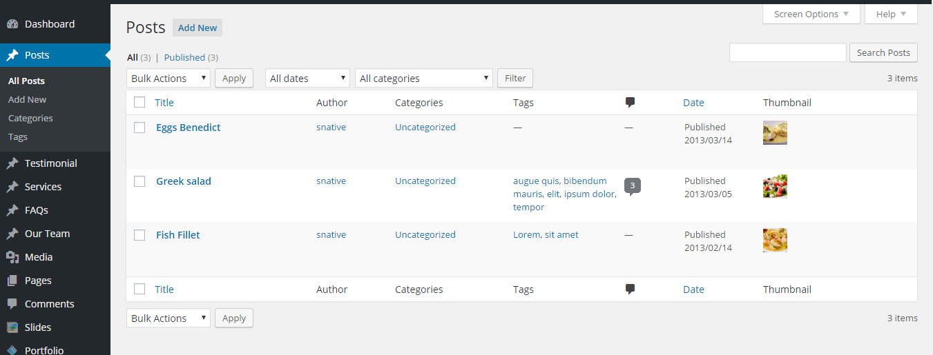

**How to change the pages content’s**

Admin can easily add, edit or delete the content from exiting pages by using admin panel. To modify the existing pages content or to add new page with content follows the below steps.

**Step1:** Login into your admin panel.

**Step2:** Click on `Pages` from navigation bar. After you clicked on Pages link you will find the list of existing pages.

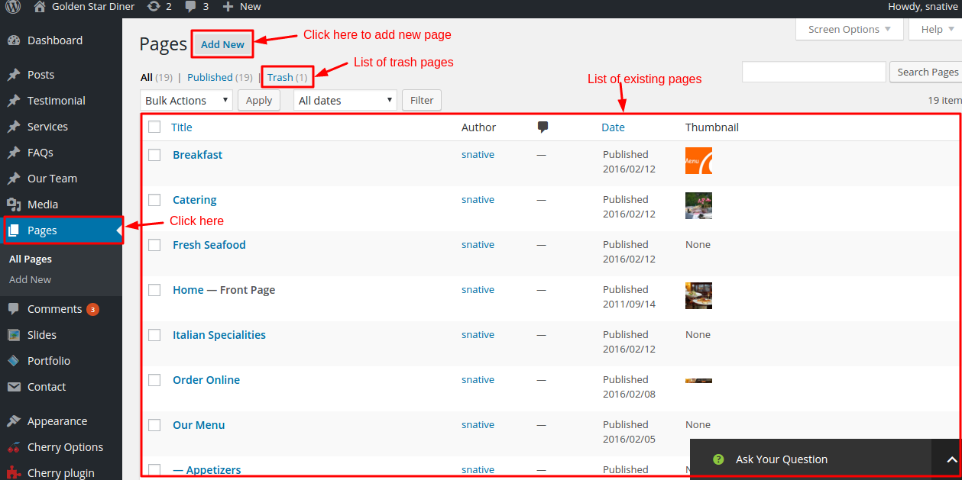

**1. Edit Home Page**

Admin can edit find and edit the content of the Home page. To edit home page find the page called `Home – Front Page` from the list of pages and click on it.

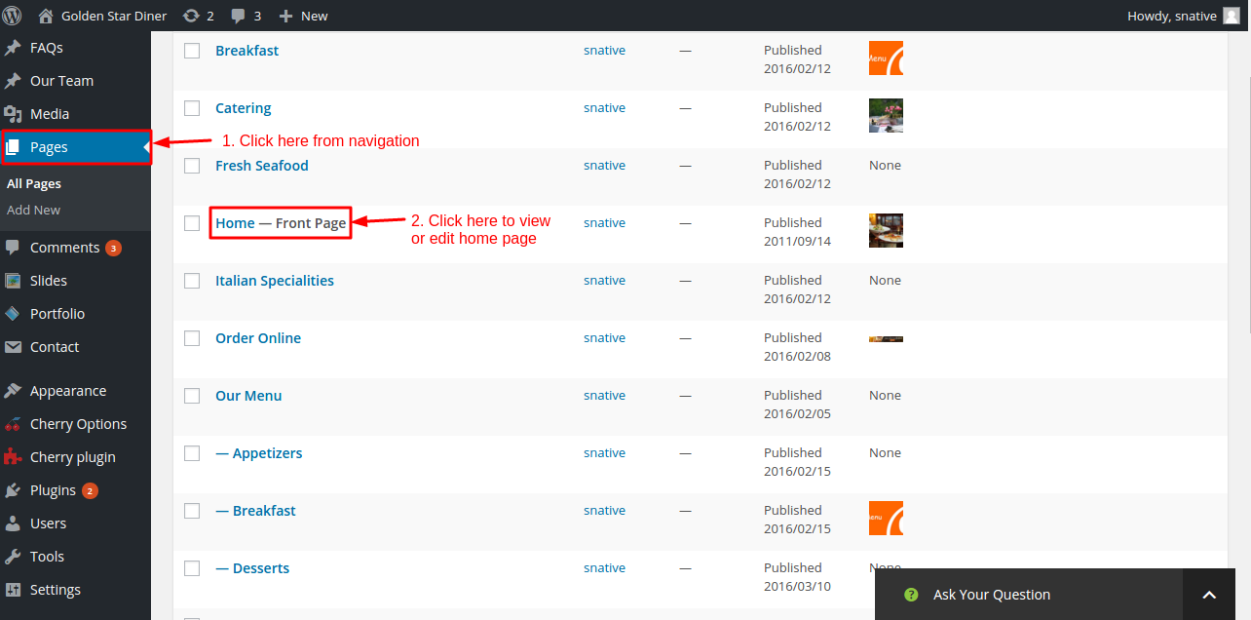

After clicking on `Home-Front Page` admin can find following edit page screen.

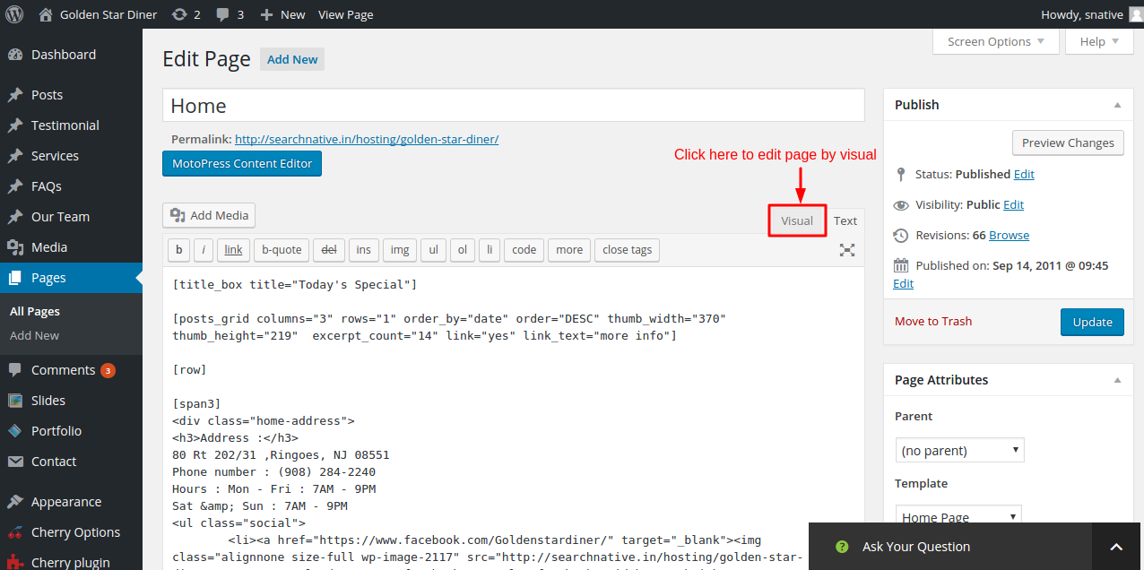

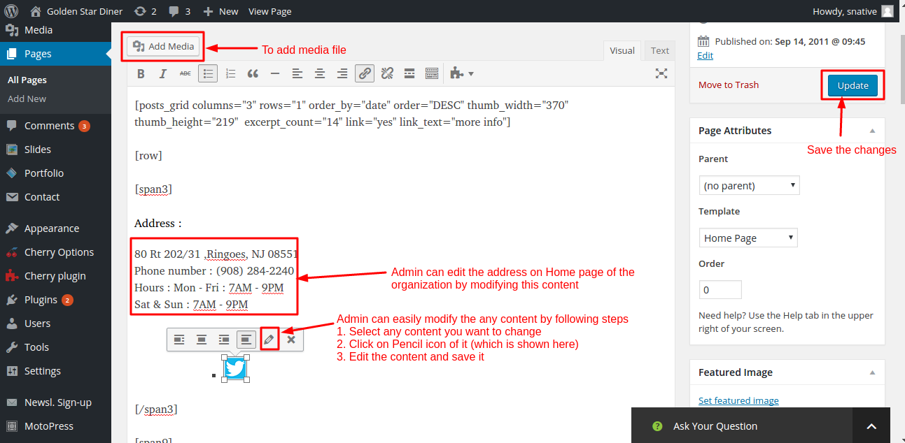

**2. Edit the About us Page**

To view or edit the about us page find the `About Us` page from the page list and click on it.

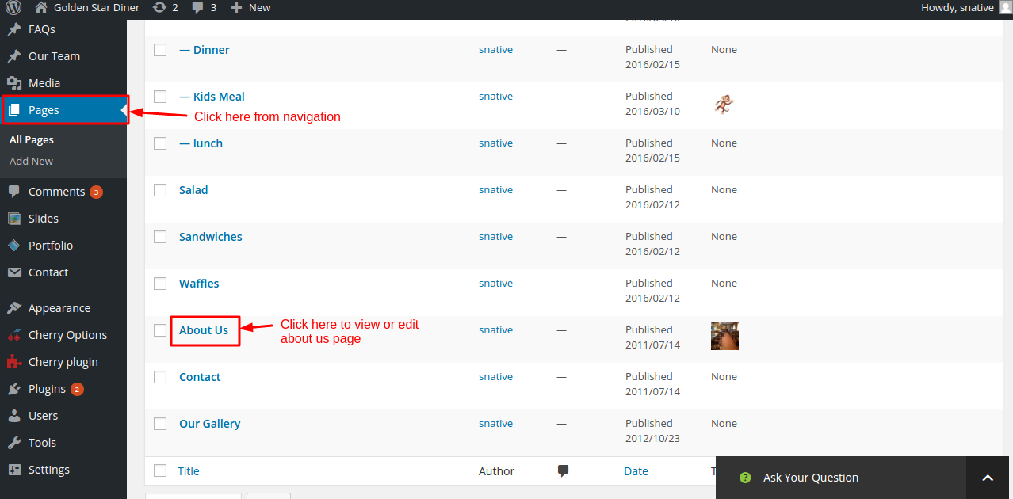After clicking on it admin can find following screen and follows the steps which is highlighted on snapshot.

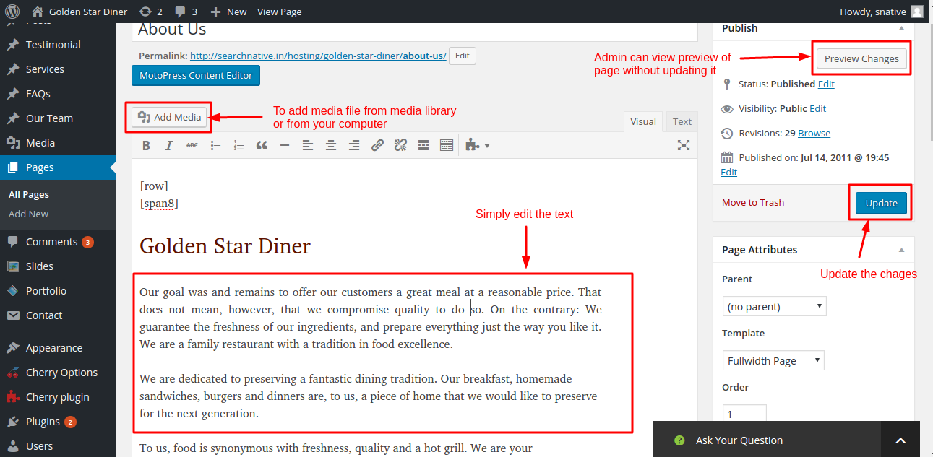**3. How to edit Order Online Page**

To view or edit order online page find the `Order Online` page from page list and click on it. After clicking on it you will find the following screen and follows the step which is given in snapshot.

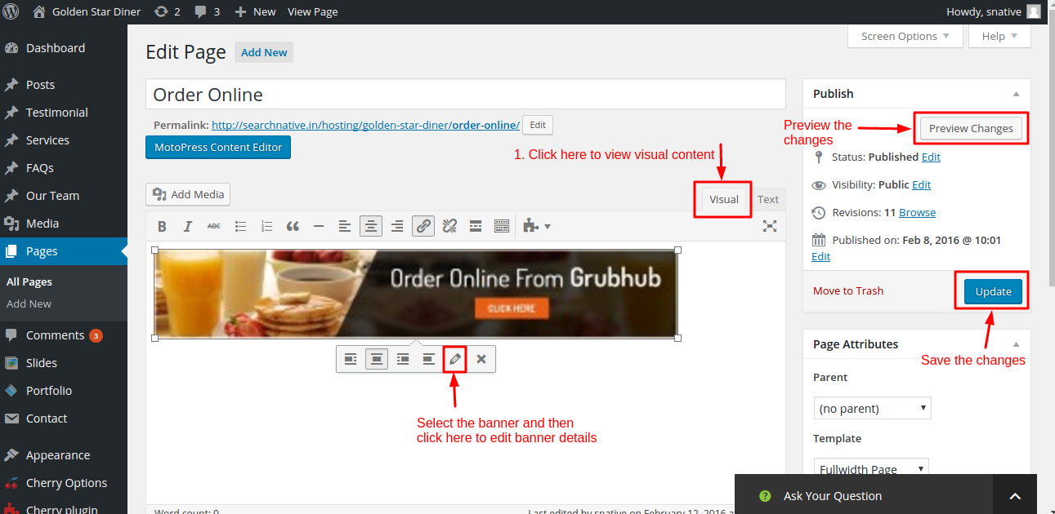After clicking on edit link you will find the below screen and follows the steps which is given in screen.

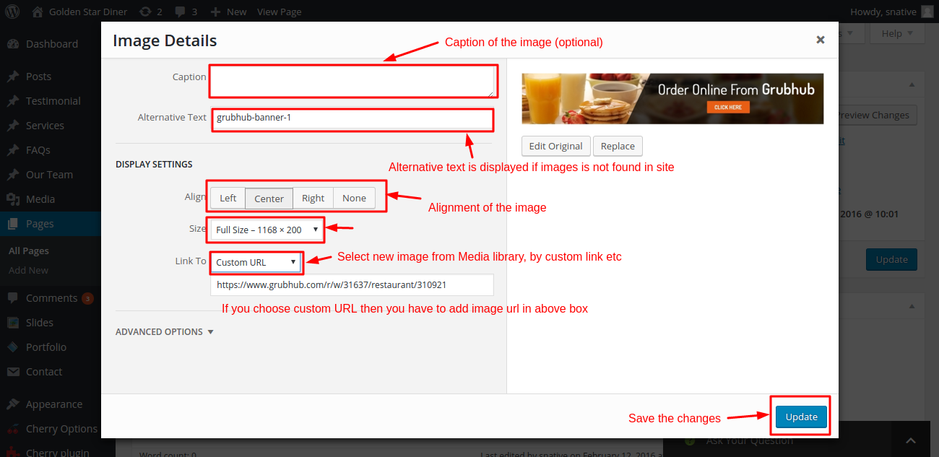

**4. How to change Catering Page**

To view or edit the catering page follows the below steps

**Step1:** Go to `Contact` from navigation

**Step2:** Find the `catering request form new` from list and click on it. After clicking on it you will find the below screen and follows the step which is given in snapshot.

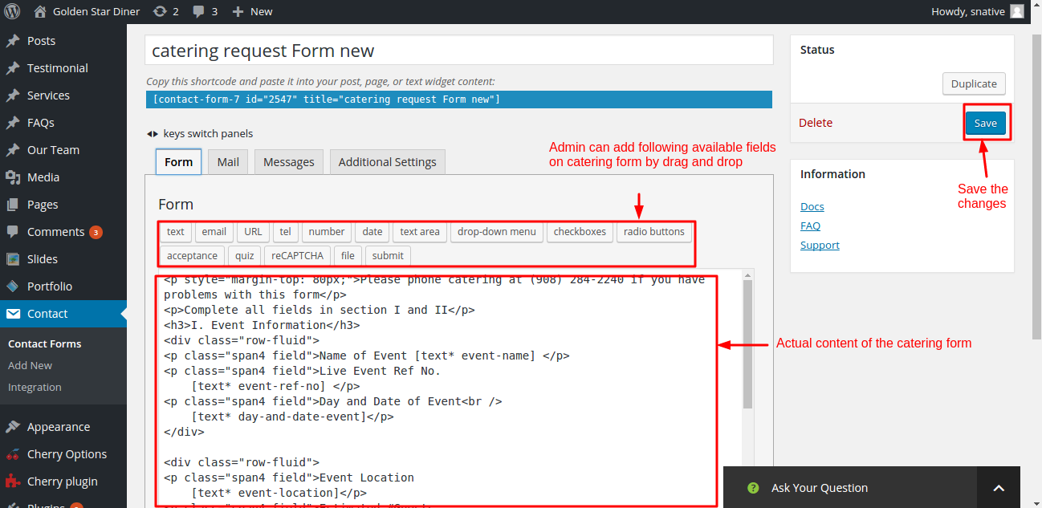If you want to change the mail notification of the catering requests hust click on `Mail` link which is available on form and follows the step which is given in snapshot.

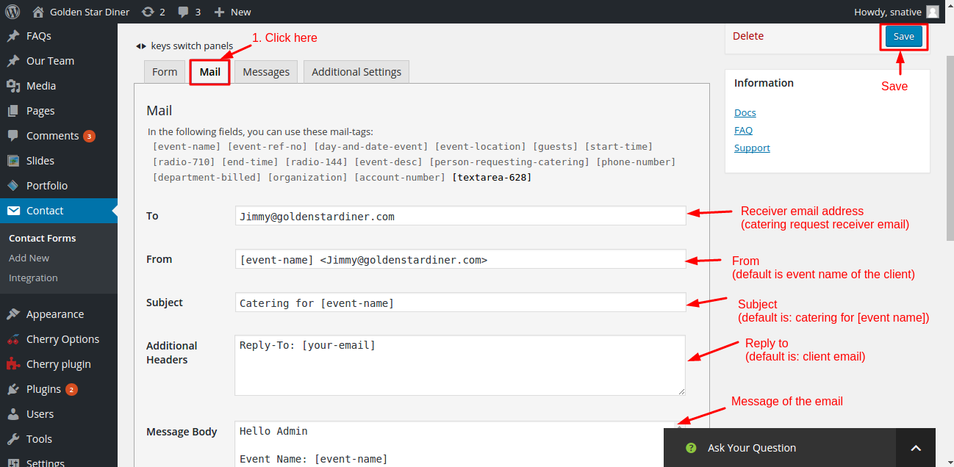

**5. Edit the Gallery Page**

**Note: To edit gallery page refer the `Manage your portfolio` from the documentation.**

**6. How to edit Contact Page**

**Note: To edit contact page refer the `Mange your contact form` from the documentation.**

To edit the contact details of the contact page follows the below steps:

**Step1:** Go to `Pages` from navigation.

**Step2:** Find the `Contact` from the page list and click on it

